PART 1:

## **First VidCast**

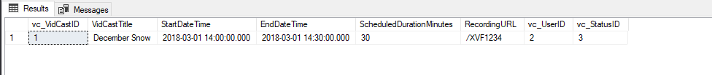

## **Saul’s First VidCast**

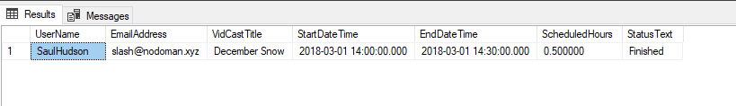

## **Update a User**

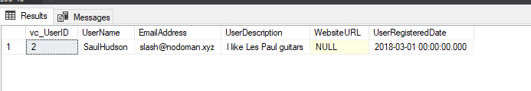

## **No More on Time**

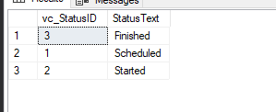

PART 2:

## **Tags**

--PART 2---

--Adding Rows to vc_Tag, Test--

INSERT INTO vc_Tag (TagText,TagDescription)

VALUES ('Personal', 'About people')

--Adding rest of the rows to vc_Tag

INSERT INTO vc_Tag (TagText, TagDescription)

VALUES ('Professional', 'Business, buisness, business'), ('Sports', 'All manner of sports')

, ('Music', 'Music analysis, news, and thoughts'), ('Games', 'Live streaming our favorite games');

--Review Table--

SELECT * FROM vc_Tag

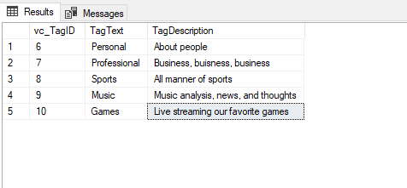

## **Users**

--Insert New Users into vc_User table

INSERT INTO vc_User(UserName, EmailAddress, UserDescription)

VALUES

('TheDoctor', 'tomBaker@nodomain.xyz', 'The definite article'),

('HairCut', 'S.todd@nodomain.xyz', 'Fleet Street barber shop'),

('DnDGal', 'dnd@nodomain.xyz', ' ')

SELECT * FROM vc_User

--Realized that the DnDGal's UserDescription should state "Null" not be blank.

--Therefore, in order to rectify this error....

- --Step 1 : Delete the row

DELETE vc_User WHERE UserDescription = ' '

--STEP 2: Review Table to make sure it was deleted correctly.

SELECT * FROM vc_User

--Step 3: Add in the row Correctly.

INSERT INTO vc_User(UserName,EmailAddress)

VALUES

('DnDGal', 'dnd@nodomain.xyz')

--Review Table

SELECT * FROM vc_User

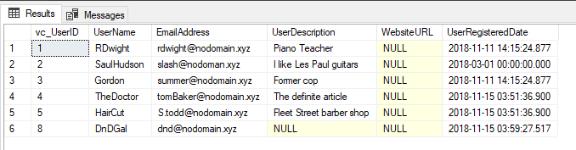

## **User Tag List**

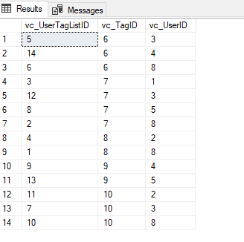

## **User Tags Report**

--Select UserName, EmailAddress, and TagText for all vc_User Records

SELECT

vc_User.UserName,

vc_User.EmailAddress,

vc_Tag.TagText

FROM vc_UserTagList

JOIN vc_User ON vc_UserTagList.vc_UserID = vc_User.vc_UserID

JOIN vc_Tag ON vc_UserTagList.vc_TagID = vc_Tag.vc_TagID

ORDER BY vc_User.UserName, vc_Tag.TagText

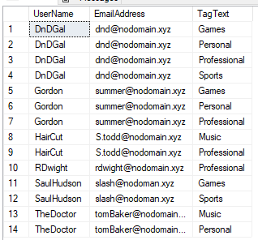

SQL Query File :

--Adding a row to the vc_Status table

INSERT INTO vc_Status (StatusText)

VALUES ('Scheduled')

--The following line shows all of the rows in vc_Status

SELECT * FROM vc_Status

--Adding three more rows to the vc_status table

INSERT INTO vc_Status (StatusText)

VALUES ('Started'), ('Finished'), ('On time')

--Statment to find value of vc_UserID for vc_User with UserName SaulHudson

--Statement to find value of vc_StatusUd for vc_Status with StatusText of Finished

SELECT * FROM vc_User WHERE UserName = 'SaulHudson'

SELECT * FROM vc_Status WHERE StatusText = 'Finished'

--Adding a vidcast record of the Vidcast Table

INSERT INTO vc_VidCast

(VidCastTitle, StartDateTime, EndDateTime, ScheduledDurationMinutes

, RecordingURL, vc_UserID, vc_StatusID)

VALUES

('December Snow', '3/1/2018 14:00', '3/1/2018 14:30', 30

, '/XVF1234', 2, 3)

--Read all rows from vc_VidCast

SELECT * FROM vc_VidCast

--Complete Query

SELECT

vc_User.UserName,

vc_User.EmailAddress,

vc_VidCast.VidCastTitle,

vc_VidCast.StartDateTime,

vc_VidCast.EndDateTime,

vc_VidCast.ScheduledDurationMinutes / 60.0 as ScheduledHours,

vc_Status.StatusText

FROM vc_VidCast

JOIN vc_User ON vc_VidCast.vc_UserID = vc_User.vc_UserID

JOIN vc_Status ON vc_VidCast.vc_StatusID = vc_Status.vc_StatusID

WHERE vc_User.UserName = 'SaulHudson'

ORDER BY vc_VidCast.StartDateTime

--Correcting a User's UserRegisteredDate

UPDATE vc_User SET UserRegisteredDate = '3/1/2018' WHERE UserName = 'SaulHudson'

SELECT * FROM vc_User WHERE UserName = 'SaulHudson'

--See what rows we have in Status

SELECT * FROM vc_Status

--Delete the On time Status

DELETE vc_Status WHERE StatusText = 'On time'

--See the effect

SELECT * FROM vc_Status

--PART 2---

--Adding Rows to vc_Tag, Test--

INSERT INTO vc_Tag (TagText,TagDescription)

VALUES ('Personal', 'About people')

--Adding rest of the rows to vc_Tag

INSERT INTO vc_Tag (TagText, TagDescription)

VALUES ('Professional', 'Business, buisness, business'), ('Sports', 'All manner of sports')

, ('Music', 'Music analysis, news, and thoughts'), ('Games', 'Live streaming our favorite games');

--Review Table--

SELECT * FROM vc_Tag

--Adding Users to vc_User table

SELECT * FROM vc_User

--Insert New Users into vc_User table

INSERT INTO vc_User(UserName, EmailAddress, UserDescription)

VALUES

('TheDoctor', 'tomBaker@nodomain.xyz', 'The definite article'),

('HairCut', 'S.todd@nodomain.xyz', 'Fleet Street barber shop'),

('DnDGal', 'dnd@nodomain.xyz', ' ')

SELECT * FROM vc_User

--Realized that the DnDGal's UserDescription should state "Null" not be blank.

--Therefore, in order to rectify this error....

- --Step 1 : Delete the row

DELETE vc_User WHERE UserDescription = ' '

--STEP 2: Review Table to make sure it was deleted correctly.

SELECT * FROM vc_User

--Step 3: Add in the row Correctly.

INSERT INTO vc_User(UserName,EmailAddress)

VALUES

('DnDGal', 'dnd@nodomain.xyz')

--Review Table

SELECT * FROM vc_User

--Appendix B, Users Can Add tags to their user account

INSERT INTO vc_UserTagList (vc_UserID, vc_TagID)

VALUES

((SELECT vc_UserID FROM vc_User WHERE UserName='DnDGal'),

(SELECT vc_TagID FROM vc_Tag WHERE TagText='Sports')),

((SELECT vc_UserID FROM vc_User WHERE UserName='DnDGal'),

(SELECT vc_TagID FROM vc_Tag WHERE TagText='Professional')),

((SELECT vc_UserID FROM vc_User WHERE UserName='RDwight'),

(SELECT vc_TagID FROM vc_Tag WHERE TagText='Professional')),

((SELECT vc_UserID FROM vc_User WHERE UserName='SaulHudson'),

(SELECT vc_TagID FROM vc_Tag WHERE TagText='Sports')),

((SELECT vc_UserID FROM vc_User WHERE UserName='Gordon'),

(SELECT vc_TagID FROM vc_Tag WHERE TagText='Personal')),

((SELECT vc_UserID FROM vc_User WHERE UserName='DnDGal'),

(SELECT vc_TagID FROM vc_Tag WHERE TagText='Personal')),

((SELECT vc_UserID FROM vc_User WHERE UserName='Gordon'),

(SELECT vc_TagID FROM vc_Tag WHERE TagText='Games')),

((SELECT vc_UserID FROM vc_User WHERE UserName='HairCut'),

(SELECT vc_TagID FROM vc_Tag WHERE TagText='Professional')),

((SELECT vc_UserID FROM vc_User WHERE UserName='TheDoctor'),

(SELECT vc_TagID FROM vc_Tag WHERE TagText='Music')),

((SELECT vc_UserID FROM vc_User WHERE UserName='DnDGal'),

(SELECT vc_TagID FROM vc_Tag WHERE TagText='Games')),

((SELECT vc_UserID FROM vc_User WHERE UserName='SaulHudson'),

(SELECT vc_TagID FROM vc_Tag WHERE TagText='Games')),

((SELECT vc_UserID FROM vc_User WHERE UserName='Gordon'),

(SELECT vc_TagID FROM vc_Tag WHERE TagText='Professional')),

((SELECT vc_UserID FROM vc_User WHERE UserName='HairCut'),

(SELECT vc_TagID FROM vc_Tag WHERE TagText='Music')),

((SELECT vc_UserID FROM vc_User WHERE UserName='TheDoctor'),

(SELECT vc_TagID FROM vc_Tag WHERE TagText='Personal'))

SELECT * FROM vc_UserTagList

--Select UserName, EmailAddress, and TagText for all vc_User Records

SELECT

vc_User.UserName,

vc_User.EmailAddress,

vc_Tag.TagText

FROM vc_UserTagList

JOIN vc_User ON vc_UserTagList.vc_UserID = vc_User.vc_UserID

JOIN vc_Tag ON vc_UserTagList.vc_TagID = vc_Tag.vc_TagID

ORDER BY vc_User.UserName, vc_Tag.TagText

--THE END of LAB 6 --